Views of Christian Creationism

Although all Christians believe in creation by a Creator, they do not agree about the mechanism used.

A. The Biblical Account

We begin with the record in the Hebrew Scripture from Genesis 1:1-2:4a.

”In the beginning God created the heavens and the earth. The earth was barren, with no form of life; it was under a roaring ocean covered with darkness. (Genesis 1:1,2)
On day 1 God said, “Let there be light” and light was separated from darkness.
On day 2 God divided the waters above from the waters below by creation of a firmament.
On day 3 God separated the dry land from the seas and commanded the earth to produce plants. (Was this by a different mechanism?)
On day 4 God created two “great lights”, the sun and the moon as well as the stars.
On day 5 God commanded the earth to produce the birds and the sea to produce creatures of the sea.
On day 6 God commanded the earth to produce land creatures and then God created humans.

There is a second account of creation in Genesis 2:4b-25, which begins with “When the LORD God made the heavens and the earth, no grass or plants were growing anywhere. God had not yet sent any rain, and there was no one to work the land.”

Then in order God created:
Water (streams which came up from the earth)
Adam
The garden of Eden and vegetation
Four rivers (including Tigris and Euphrates)
Land animals, birds ( fish are not mentioned)
Eve ( from Adam's rib)
Note that Adam is created at the very end of creation in Genesis 1 and much earlier in Genesis 2.

The cosmology of this text is based on the Mesopotamian view of the the firmament and waters above and waters below.

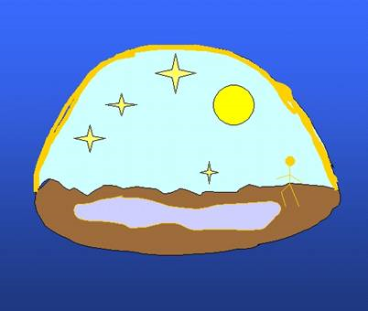

The Egyptians incorporated mythology into their cosmology as illustrated next:

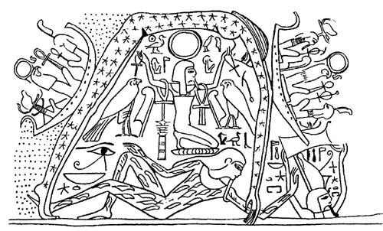

Here is shown Nut, the goodess of the sky, whose body contains the stars and arches over the Earth god, Geb, lying below. The sun god, Re, is sailing on his ship on the left on his daily course. He appears again on the right in the afternoon and is headed toward Osiris, the god of the dead, on his way to the waters under the earth where he will sail to prepare for the next day.

The Hebrew statement, ”In the beginning God created the heavens and the earth”, was possibly not so much of a historical statement as a theological one. It states clearly that here is one God, not many gods, and that He is the creator of the earth.

The early Church Fathers did not necessarily treat these accounts literally:

Origen (c. 185–254 ), wrote in his On First Principles 4.3.1 “ Now what man of intelligence will believe that the first and the second and the third day, and the evening and the morning existed without the sun and moon and stars? . . . I do not think anyone will doubt that these are figurative expressions which indicate certain mysteries through a semblance of history and not through actual events.
Augustine (354-430 A.D.) said in his work The City of God, “What kind of days these were it is extremely difficult, or perhaps impossible for us to conceive…” Augustine believed in “instantaneous creation”, a non-literal view of the six-day creation account. Augustine’s view was prominent into the Middle Ages.
Usser's Chronology
In 1650, Archbishop Ussher published a chronology dating the creation to the night preceding October 23, 4004 BC. Ussher's proposed date of 4004 BC differed little from other Biblically-based estimates, such as those of Johannes Kepler (4977 BC), or Sir Isaac Newton (c. 4000 BC.) Usshur's Chronology was based on the genealogies of Genesis 5 and 11, which in Hebrew writing were often telescoped. An example is the genealogy in Matthew 1:8 where Jehoram is descibed as the father of Uzziah, while in I Chronicles 3:12 he is described as the great-grandson.

It was also common in ancient genealogies to have ten-name lists, such as Adam to Noah and Noah to Abraham. Genealogies were used to establish lineage, not necessarily exact parentage.

In 1675 a bookseller named Thomas Guy began including Ussher's dates in the King James version of the Bible. In 1701, the Church of England adopted Ussher’s dates for use in its official Bible. For the next two centuries, Ussher’s dates so commonly appeared in Bibles that his dates “practically acquired the authority of the word of God.”

B. The scientific view of the age of the earth and the universe:
Science contradicts the 6000 year age of the universe in at least three areas:

1. Fossils in rocks, dated by radiometry as long as 4.5 million years ago. Let us first look at the fossil record, a cross section of the Grand Canyon.
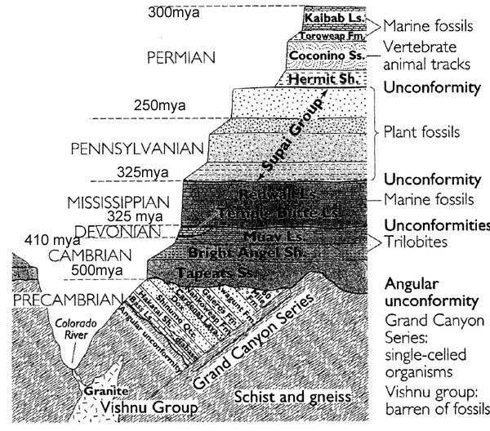

Here we see a record of some of the fossils found and the relative ages of the rocks where they are found. The age of the rock is determined by radiometry , where the radioactive decay of the elements in the rocks is measured.

Geology tells us that rocks on earth are as old as 4.5 billion years. One of the methods geologists use to establish this date is radiometric testing.
If a rock is young, the ratio 204Pb/207Pb will be nearly identical to the current ratio of those two isotopes. If billions of years have passed, there will be very little 235U and 204Pb/207Pb will be small, because of the accumulation of 207Pb over time.
There are other uranium, potassium-argon and thorium methods for dating rock, each based on a different isotope series, and each providing an independent check on the others.
Although they do not give exact times, erosion and geologic strata all confirm the radiometric dating in terms of order. That is, normally newer strata will lie above older strata. See the cross section of Grand Canyon below.

Finally, the study of tectonic plates is interesting in the formation of the present continents, but only measure time back about 750 million years. There is a nice animation of continental drift at http://www.ucmp.berkeley.edu/geology/anim1.html

2. Continental Drift: Scientists tell us that about 200 million years ago there was one large continent named Pagea, from which eventually came 4 of the present continents. Not only do the continents seem to fit visually, but there similar fossil remains in South America and Africa, the one a freshwater reptile. It is difficult to explain how this fossil would appear in both continents if thye had not at some time, been contiguous.

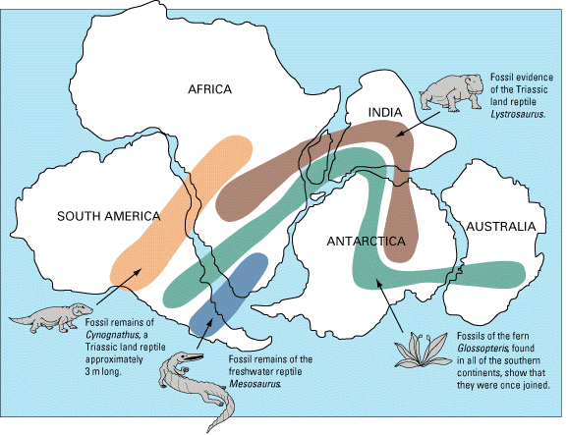

At the rate at which the tectonic plates move, scientists tell us that it took about 200 million years from this position of the continents to their present position. This far exceeds the 6,000 years of Ussher.

- Astronomers tell us that light travels at 186,000 miles/second and light from the sun takes 8 minutes to get to the earth. This is also called look-back time, since we are seeing the sun as it was 8 minutes ago. The nearest star (beside the sun) is over 4 light-years away. The Orion constellation is over 1,300 light-years away.

Astronomers, using “red shift” and cosmic microwave background radiation tell us that the universe is about 14 billion years old.

If the universe were only 6,000 years old, we would not be able to see any heavenly objects more than 6,000 light-years away. Yet we can see the Andromeda Constellation with small telescopes, even faintly with the naked eye and it is 2.5 million light-years away. (See sketch below.)

Our galaxy, the Milky Way, is about 100,000 light years in diameter. The next picture shows a circle(in red) of radius 10,000 light-years imposed on the Milky Way. It is clear that we would only be able to see a small part of our own galaxy if the universe were only 10,000 years old.

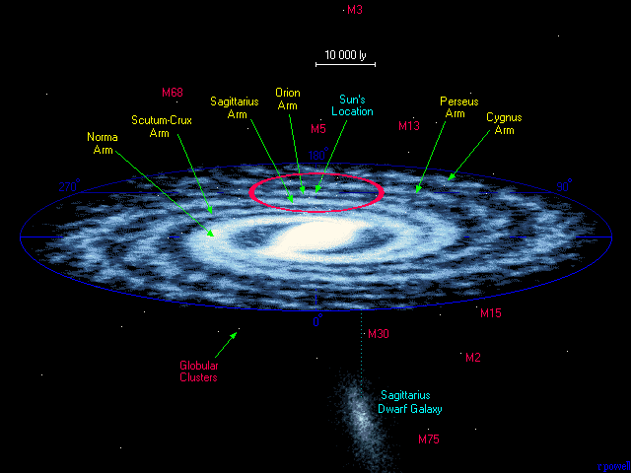

Scientific explantion of evolution:

1. Mutations are changes in DNA which may occur as simple copying errors when DNA replicates itself or as a result of DNA damage through environmental agents.

Some mutations are favorable and some are unfavorable. Breeders use these mutations to their benefit and develop breeds with desirable features.


“Nature” does the same with natural selection. The natural genetic variation, or mutations, within a population of organisms may cause some individuals to survive and reproduce more successfully than others in their current environment.

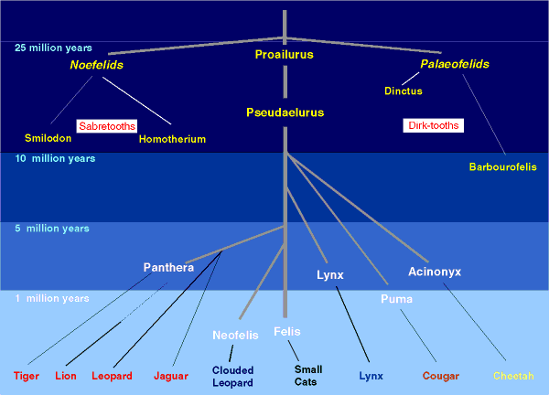

This also shows common ancestry.




Proailurus Pseudaelurus

3. Common ancestry
a. Suggested by anatomical similarities.Frogs, birds, rabbits and lizards all have different forelimbs, all of which share the same set of bones - the humerus, the radius, and the ulna.
This is also true of the eusthenopteron of 370 mya.

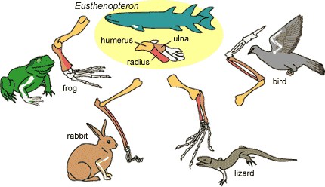

b. Human-Great Ape Family (Hominidae)
98% DNA similarity with chimpanzees
Vestigial structures: appendix, tailbone
Vestigial genes, example of pseudogene for Vitamin C
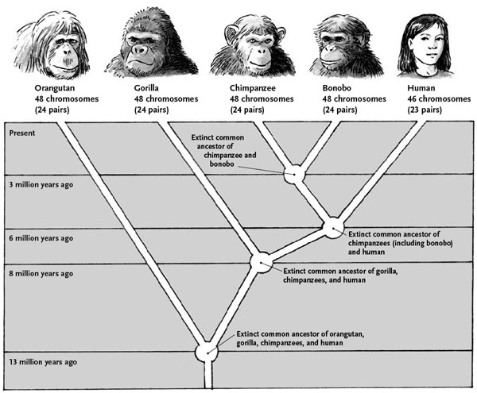

Facts supporting common ancestry

1. Human-Primate Pseudogenes
In mice and rodents and most other mammals, the gene sequence includes a gene for making Vitamin C, so the mice don't have to eat citrus or other sources of Vitamin C.

In primates, the gene sequence includes a non-functioning pseudogene, having almost identical encoding as the real gene, but with some errors that make it non-functional. As a consequence, primates require an external source of Vitamin C to avoid scurvy.

2. Human chromosome 2

In the left drawing below we see the human chromosome 2 compared with the the two chimpanzee chromosomes, 2p and 2q. Note that the top half of the human chromosome matches the chimp 2p chromosome and the bottom half of the hman chromosome matches the chimp 2q choromosome. Recalling that humans have 23 pairs of chromosomes and that chimps have 24, evolution suggests that in some ancestor of humans and chimps, through some mutation “error” the two chimp chromosomes were fused into one, yielding a new species with 23 pairs of chromosomes rahter than 24.

This is further suggested in the right hand sketch, again comparing the single human chromosome with the two chimp chromosomes. All chromosomes have a telomere (a cap) at each end for protection, as well as a centromere at some point inside the chromosome. Note that the human chromosome has a telomere in the middle and two entromeres.

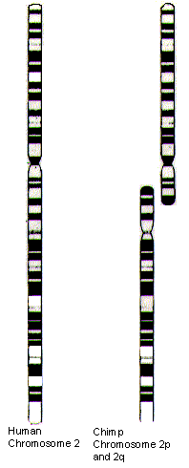

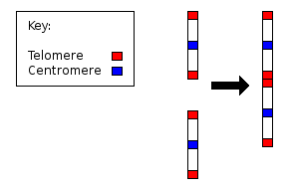

C. What are Christian Creationist's Views?

1. Young-earth Creationism
Began with fundamentalist Christianity (1910-1915 ) - literal interpretation of the Bible
George McCready Price, The New Geology, 1923
Henry Morris, The Genesis Flood, 1961
Institute for Creation Research, www.icr.org
Answers in Genesis, www.answersingenesis.org
Museums

Beliefs:
Creation in six 24 hour days
Flood geology (fossils stratified by flood)
Young earth - 6,000 to 10,000 years old
Dinosaurs and humans lived at the same time
Appearance of age
Rapid (or no) continental drift
Limited or no common ancestry, especially for humans

Critical comment by Kenneth R. Miller
“In order to defend God against the challenge they see from evolution, [creationists] have had to make Him into a schemer, a trickster, even a charlatan. Their version of God is one who intentionally plants misleading clues beneath our feet and in the heavens themselves. To embrace that God, we must reject science and worship deception itself.”

2. Progressive Creationism
Accepts scientific age of earth and a literal interpretation of Genesis 1 except for length of “days.” (The Hebrew word “yom” can mean longer periods of time.)
Creation days are geological ages.
Support creation of new “kinds” of plants and animals by God's direct intervention, with no macroevolution of “kinds.”

Hugh Ross, Reasons to Believe organization, www.reasons.org

Progressive Creationism
Day 1 15 bya to 3.9 bya (universe, earth )
Day 2 2.7 bya (continents on earth)
Day 3 900mya (creation of plants on land)
Day 4 900-600mya (atmosphere from translucent to transparent)
Day 5 500mya-60 mya (creation of sea animals and birds)
Day 6 30 mya-50kya (creation of land mammals and humans)

Problems
In Genesis plants appear on the third day and animals on the fifth day. Geology states that invertebrates were swarming in the sea before vegetation appeared on land.
In Genesis, birds were created before land mammals, and sea mammals before land mammals. Science teaches the reverse.
Progressive creationists have the separation of continents 2.7bya-900mya while scientists have continental drift beginning about 200mya.

3. Intelligent Design
Based on irreducible complexity- certain biological systems are too complex to have evolved from simpler predecessors, through natural selection acting upon a series of advantageous naturally-occurring, chance mutations.
An intelligent designer intervened at those points.

One example – the human eye, with its retina, optic nerve, pupil, iris, cornea and lens.

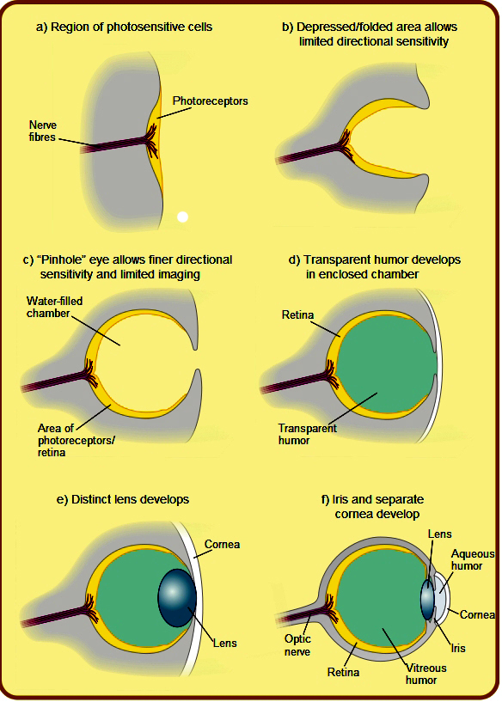
Eyes in Existing Species
Pit “eyes” - flatworm
Cups – limpet
Pinhole Cameras- chambered nautilus
Transparent Cover - marine rag-worm
Lens – squid – focuses by changing position

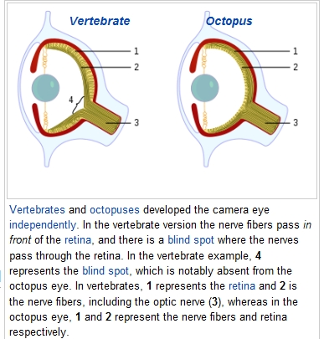
Two Different Retina Designs

Other “Bad Designs”
The Psalmist says ”we are fearfully and wonderfully made,” but there are design “problems” in humans: appendix, prostate, wisdom teeth, layrngeal nerve.
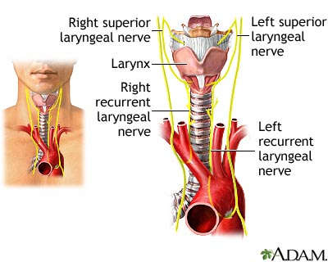

Many species went extinct! Many versions of the elephant before the Proboscidea genus. Same for hominids (over 20 species, including Lucy of 6mya and the Neanderthals of 200-30kya).

4. Evolving Creationism
Sometimes called “theistic evolution.”
Belief: God used evolution as a tool of creation and the “big bang” as the way of beginning the process. The Big Bang theory validates the Christian concepts of a finite universe, an initial beginning and a creation of time and space.
Not a new scientific theory, but a view about how evolution relates to religious belief in a Creator.

Statements of support:

Statement by Dr. Francis Collins, former director of the Human Genome Project and now director of the National Institute of Health:

“I see no conflict in what the Bible tells me about God and what science tells me about nature. Like St. Augustine in A.D. 400, I do not find the wording of Genesis 1 and 2 to suggest a scientific textbook but a powerful and poetic description of God's intentions in creating the universe. The mechanism of creation is left unspecified. If God, who is all powerful and who is not limited by space and time, chose to use the mechanism of evolution to create you and me, who are we to say that that wasn't an absolutely elegant plan?”

Statement by Dr. Denis Lamoureaux
“At conception, the DNA in a fertilized human egg is fully equipped with the necessary information for a person to develop during the nine months of pregnancy.
Similarly, the Creator loaded into the Big Bang the plan and capability for the cosmos and living organisms, including humans, to evolve over 10–15 billion years.”

Statement by Dr. Theodosius Dobzhansky
"I am a creationist and an evolutionist. Evolution is God's, or Nature's, method of creation. Creation is not an event that happened in 4004 BC; it is a process that began some 10 billion years ago and is still under way... Does the evolutionary doctrine clash with religious faith? It does not. It is a blunder to mistake the Holy Scriptures for elementary textbooks of astronomy, geology, biology, and anthropology. If the text is construed to mean that, the Creator is accused of systematic deceitfulness."

Statement by Charles Krauthammer, reporting on the 2005 Dover,PA school trial on teaching intelligent design:

“How ridiculous to make evolution the enemy of God. What could be more elegant, more simple, more brilliant, more economical, more creative, indeed more divine than a planet with millions of life forms, distinct and yet interactive, all ultimately derived from accumulated variations in a single double-stranded molecule, pliable and fecund enough to give us mollusks and mice, Newton and Einstein? “

Genetic Automata Analogy to compare the different views of creationism:
Assume creation by a creator, using genetic robots, or automata, which are controlled by “genetic algorithms.”
Young earth – a robot for every “kind” or species.

Progressive creation - more capable algorithms, some microevolution, with creator's intervention.

Intelligent design – additional algorithms for each complex event like the eye or blood clotting.

Evolving creationism: one genetic automaton at the “big bang” with algorithms capable of all the potential of evolution.

Denominational Responses: (from Am I a Monkey? Six Big Questions About Evolution, by Francisco J. Ayala)

Pope Pius XIII in 1959 encyclical Human Generis (On the Human Race) asserted that biological evolution was compatible with the Christian faith. Pope John Paul II, in an address to the Pontifical Academy of Sciences on October 22, 1996, said: "New scientific knowledge has led us to realize that the theory of evolution is no longer a mere hypothesis. It is indeed remarkable that this theory has been progressively accepted by researchers, following a series of discoveries in various fields of knowledge. The convergence, neither sought nor fabricated, of the results of work that was conducted independently is in itself a significant argument in favor of this theory."

The General Assembly of the United Presbyterian Church in 1982 adopted a resolution stating that "Biblical scholars and theological schools ... find that the scientific theory of evolution does not conflict with their interpretation of the origins of life found in Biblical literature."

The Lutheran World Federation in 1965 affirmed that "evolution's assumptions are as much around us as the air we breathe and no more escapable. ... [B]oth science and religion are here to stay, and... need to remain in a healthful tension of respect toward one another." Similar statements have been advanced by Jewish authorities and leaders of other major religions. In 1984, the Ninety-fifth Annual Convention of the Central Conference of American Rabbis adopted a resolution stating: "Whereas the principles and concepts of biological evolution are basic to understanding science ... we call upon science teachers and local school authorities in all states to demand quality textbooks that are based on modern, scientific knowledge and that exclude 'scientific' creationism."

There is an Episcopal response in its Catechism of Creation at www.episcopalchurch.org/19021_58398_ENG_HTM.htm

The "Clergy Letter Project," signed by more than twelve thousand U.S. Christian clergy members, makes a similar point: "We the undersigned, Christian clergy from many different traditions, believe that the timeless truths of the Bible and the discoveries of modern science may comfortably coexist. We believe that the theory of evolution is a foundational scientific truth, one that has stood up to rigorous scrutiny and upon which much of human knowledge and achievement rests. To reject this truth or to treat it as 'one theory among others' is to deliberately embrace scientific ignorance and transmit such ignorance to our children. We ask that science remain science and that religion remain religion, two very different, but complementary, forms of truth."

Religious scholars in the past struggled with imperfection, dysfunction, and cruelty in the living world, which are difficult to explain if they are the outcome of God's design. The Scottish philosopher David Hume (1711-1776) set the problem succinctly with brutal directness: "Is he [God] willing to prevent evil, but not able? Then he is impotent. Is he able, but not willing? Then he is malevolent. Is he both able and willing? Whence then evil?" Evolution came to the rescue. As the theologian Aubrey Moore put it in 1891, "Darwinism appeared, and, under the guise of a foe, did the work of a friend." The theory of evolution, which at first seemed to remove the need for God in the world, now has convincingly removed the need to explain the world's imperfections as failed outcomes of God's design.

Summary :
Yes. In Christianity, Islam, and Judaism, the compatibility of science and religion has long been accepted by most scholars, by most theologians. Pope Pius XII said in 1950 that Catholics should accept what science demonstrates about evolution, while holding that God creates the human soul. In 1996, Pope John Paul II spoke very strongly in support of evolution and the idea that evolution and religion are quite compatible. The current pope, Benedict XVI, says there is plenty of scientific proof for evolution and that it is absurd to assume there is a conflict between evolution and religious faith.

Bibliography:
Evolution
Coyne, Jerry, Why Evolution is True, OUP Oxford, 2009
Dawkins, Richard, The Greatest Show on Earth, The Evidence for Evolution, Free Press, 2009
Fairbanks, Daniel J, Relics of Eden, The Powerful Evidence of Evolution in Human DNA, Prometheus Books, 2007

Young Earth Creationsim
Ham, Ken, The Lie:Evolution, New Leaf Press, 2009
Morris, Henry, Scientific Creationism, 2008

Progressive Creationism
Ross, Hugh, Genesis One: A Scientific Perspective, Reasons To Believe, 2006

Intelligent Design:
Behe, Michael, Darwins' Black Box, The Biochemical Challenge to Evolution, Free Press, 2006
Meyer, Stephen, The Signature in the Cell:DNA and the Evidence for Intelligent Design, Harper, 2010
Dembski, William and Witt, Jonathan, Intelligent Design Uncensored, IVP Books , 2011

Evolving Creationism
Ayala, Francisco J. , Am I a Monkey? Six Big Questions About Evolution, Johns Hopkins University Press, 2010
Collins, Francis S., The Language of God: A Scientist Presents Evidence for Belief, Free Press, 2006
Lamoureux, Denis., Evolutionary Creation: A Christian Approach to Evolution, Luttherworth Press, 2009. See also http://www.ualberta.ca/~dlamoure/evolutionary_creation.pdf
Miller, Kenneth, Finding Darwin's God: A Scientist's Search for Common Ground Between God and Evolution, Harper Perrenial, 2007

Internet:
www.asa3.org/ASA/topics/Evolution/index.html, articles in journal of American Scientific Affiliation
www.dkiel.com/creationism - this talk in text and PowerPoint.
www.dmoz.org/Society/Religion_and_Spirituality/Christianity/Perspectives/Origins_and_Creation - a category in the Open Directory Project, edited by Don Kiel. (It may be easier to go to www.dmoz.org and then search for Creationism.) This directory is also mirrored in the Google directory at www.google.com/Top by following a similar path.

